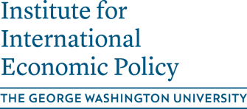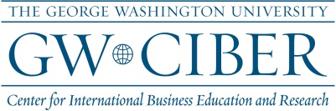

and THE GEORGE WASHINGTON UNIVERSITY CONFUCIUS INSTITUTE

6th Annual Conference on U.S.-China Economic Relations
and China’s Economic Development

November 8, 2013

1957 E ST, NW, Lindner Commons, Suite 602

Preliminary Schedule

8:45-9:00AM Welcome and Overview of the Conference

9:00-10:30AM Session 1: U.S.-China Trade: Jobs and Competition
Moderated by Michael Moore (George Washington University)
​
1. Ann Harrison (University of Pennsylvania): Industrial Policy and Competition
2. Mary Lovely (Syracuse University): Trade Liberalization and Labor Shares in China
3. Peter Schott (Yale University): The Surprisingly Swift Decline of U.S. Manufacturing Employment

10:30-11:00AM Coffee Break

11:00AM - 12:00PM Session 2: Multinational Firms in the U.S. and China
Moderated by Maggie Chen (George Washington University)

1. Lee Branstetter (Carnegie Mellon University): The Globalization of R&D: China, India, and the Rise of International Co-invention
2. Wenjie Chen (George Washington University): OFDI from China – Firm- and Transaction-level Evidence
12:00-1:30PM Lunch and Keynote – China’s Economic Development: Past, Present, and Future
1. Steve Barnett (Division Chief – China, IMF)

1:30-3:00PM Session 3: China's Growth and Financial Liberalization
Moderated by Jay Shambaugh (George Washington University)

1. Xiaodong Zhu (University of Toronto): Accounting for China's Growth
2. Chang-Tai Hsieh (University of Chicago): Institutional Foundations of China's Growth
3. Menzie Chinn (University of Wisconsin at Madison): The Rise of the "Redback" and China’s Capital Account Liberalization: An Empirical Analysis on the Determinants of Invoicing Currencies

3:00-3:30PM Coffee Break

3:30-4:30PM Session 4: China’s Economic and Political Development
Moderated by Stephen C. Smith (George Washington University)

1. James Kung (HKUST): Do Land Revenue Windfalls Reduce the Career Incentives of County Leaders? Evidence from China
2. Yan Wang (GWU, Peking University, and former World Bank): China’s Role in International Development Financing: Past, Present, and Prospect.

